# **Act Report (Udacity - Data Analyst Nanodegree Program)**

Alen Mrsic

## Analyzing data

The cleaned dataset has 1994 tweets. The first tweet from the dataset has been announced 2015-11-15 22:32:02 and last tweet at 2017-08-01 16:23:56. The average of tweet ratings for rating_numerator is 12.28 and rating_denominator 10.53.

The most favorite tweet has 143.627 likes on date 2017-01-21, post: https://twitter.com/dog_rates/status/822872901745569793/photo/1. The most favorite retweet has 77.523 likes on date 2016-06-18, post https://twitter.com/dog_rates/status/744234799360020481/video/1.

The most popular dog name in the dataset was Charlie, with following names Lucy, Oliver, Cooper. Almost all tweets, 98% prefers tweeting from an iPhone.

## Visualizing data

We can see a strong correlation between those two variables. From plot we can conclude if the tweet has more likes (more favorites), retweets are increases also.

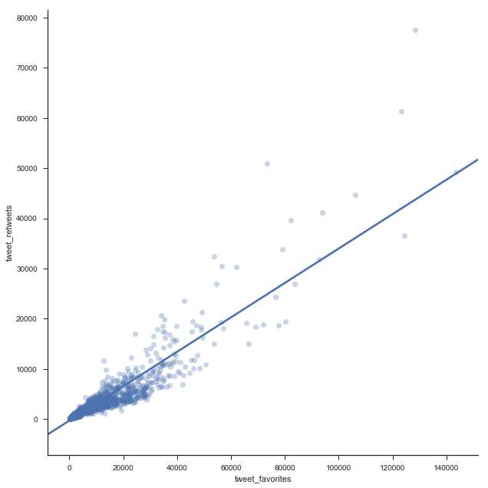

A total number of tweet favorites (likes) has increased over last three years. Total retweet has decreased in 2017. in compare with 2016.

Slika na kojoj se prikazuje snimka zaslona

Opis je generiran uz vrlo visoku pouzdanost

Over the past three years, we can see that the 1st, 6th, 7th and 12th month has in total the most likes for tweets and retweets.Slika na kojoj se prikazuje snimka zaslona

Opis je generiran uz visoku pouzdanost

Over the past 3 years, that most popular days of the month for likes and retweets are: 1st, 7th, 28th. In the middle and at the ending we see some decreasing trends.

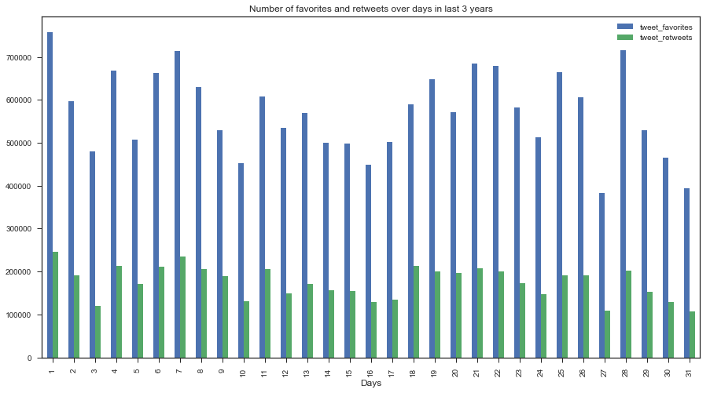

Most popular dog category has been pupper and least popular has been floofer, which is logical because smallest dogs are the cutest to people.

Slika na kojoj se prikazuje snimka zaslona

Opis je generiran uz vrlo visoku pouzdanost